Exercise: Simple and Complex Conditional Statements
Test your solutions in the judge system: https://judge.softuni.org/Contests/4400

Number Type
Write a program that:
- Reads an integer number from the console
- Based on the given number:
  - Print "negative", if the number is lower than zero
  - Print "positive ", if the number is bigger than zero
  - Print "zero ", if the number is equals to zero

Example
Input | Output |  | Input | Output |  | Input | Output
2 | positive |  | -1 | negative |  | 0 | zero

ATM
Write a program to simulate an ATM withdrawal:
- Reads 3 integer numbers which represents the following values: balance, withdraw and limit
- Based on the given input parameters:
  - Print "The withdraw was successful.", if the balance is enough
  - Print "The limit was exceeded.", if the limit is exceeded
  - Print "Insufficient availability.", if the balance isn't enough

Example
Input | Output |  | Input | Output
420  20  25 | The withdraw was successful. |  | 10  50  20 | The limit was exceeded.

Input | Output |  | Input | Output
10  20  30 | Insufficient availability. |  | 560  10  35 | The withdraw was successful.

Biggest of Five Numbers
Write a program to find the biggest among 5 numbers:
- Reads 5 integer numbers from the console
- Print the biggest number from the given five
Note: There will not be equal numbers given.

Example
Input | Output |  | Input | Output
1  2  3  4  5 | 5 |  | 10  50  20  30  40 | 50

Number Operations
Write a program to evaluate operations, which:
- Reads 2 real numbers and math operator (string) from the console
- Possible given values for the math operator are: "+", "-", "*", "/"
- Apply the operator with given numbers
- Print output in the following format, where result is formatted to the second digit:
"{N1} {operator} {N2} = {result}"

Example
Input | Output |  | Input | Output
10  12  + | 10 + 12 = 22.00 |  | 22  9  - | 22 - 9 = 13.00

Input | Output |  | Input | Output
7.6  8.2  * | 7.6 * 8.2 = 62.32 |  | 56  10  / | 56 / 10 = 5.60

Vacation Expenses
Write a program, which calculates vacation expenses:
- From the console read: season (string), accommodation type (string) and count of the days (integer)
  - Season will be one of the following: "Spring", "Summer", "Autumn" and "Winter"
  - Accommodation type will be one of the following: "Hotel" and "Camping
- Based on the table below, you have to calculate expenses for the vacation with the given accommodation type, season and count of the days.
- For the calculation: use price per night (extracted from the table below) multiplied by count of the days.
- Print the total expenses, formatted to the second digit after the decimal point

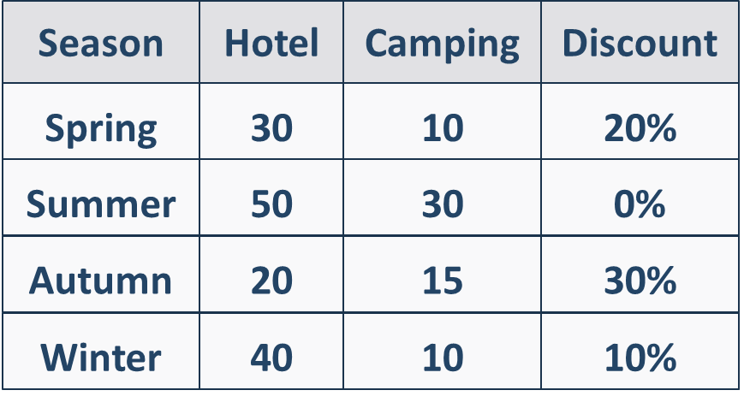

Example
Input | Output | Comments
Winter  Hotel  5 | 180.00 | Season is Winter, accommodation type is Hotel  Based on table, price per night is 40, and the discount is 10% or 0.10  Total expenses = 5 * 40 – 10% = 200 – 10% = 180.00
Summer  Camping  10 | 300.00 | Season is Summer, accommodation type is Camping  Based on table, price per night is 30, and the discount is 0%  Total expenses = 10 * 30 = 300

Product of Three Numbers
Write a program that calculates the sign of the product of three numbers:
- Reads 3 real numbers from the console
- Print the sign of the product of the three given numbers: "positive", "negative" or "zero"
Note: Try to do this without multiplying the numbers.

Example
Input | Output |  | Input | Output |  | Input | Output
2  3  -1 | negative |  | -3  -4  5 | positive |  | 0  4  5 | zero

Working Hours
Write a program that checks if the company's office is open:
- Reads an hour of the day (integer number) and a day of the week (string)
- The office's working hours are from 10 AM to 6 PM, Monday through Saturday, inclusive.
  - Print "open", if the office is open in the given hour and day of the week
  - Print "closed", if the office is closed in the given hour and day of the week

Example
Input | Output |  | Input | Output |  | Input | Output
11  Monday | open |  | 19  Friday | closed |  | 11  Sunday | closed

Fruit or Vegetable
Write a program that:
- Reads a product (string) from the console
- Based on type of the given product, print:
  - If product is one of following "banana", "apple", "kiwi", "cherry" or "lemon" you have to print "fruit"
  - If product is one of following "cucumber", "pepper" or "carrot" you have to print "vegetable"
  - If the product is different from listed products above, print "unknown"

Example
Input | Output |  | Input | Output |  | Input | Output
banana | fruit |  | pepper | vegetable |  | table | unknown

Sum Seconds
Three athletes finish in a certain number of seconds (between 1 and 50).
Write a program that:
- Read three integers - the athletes' times in seconds, from console
- Calculate their total time in the format "minutes:seconds"
Note: The seconds should be displayed with leading zero (2 as "02", 7 as "07", 35 as "35").

Example
Input | Output |  | Input | Output |  | Input | Output
35  45  44 | 2:04 |  | 22  7  34 | 1:03 |  | 50  50  49 | 2:29

Summer Outfit
Summer weather can be quite unpredictable, and Victor needs your assistance. Write a program that, based on the time of day and the temperature, recommends to Victor what clothes to wear. Your friend has different plans for each stage of the day that require varied clothing, as indicated in the table.
Two lines are read from the console:
- Temperature - an integer in the range [10... 42]
- Text, time of day - with possibilities - "Morning", "Afternoon", "Evening"
Time of day / degrees | Morning | Afternoon | Evening
10 <= temperature <= 18 | Clothing = Sweatshirt  Shoes = Sneakers | Clothing = Shirt  Shoes = Moccasins | Clothing = Shirt  Shoes = Moccasins
18 < temperature <= 24 | Clothing = Shirt  Shoes = Moccasins | Clothing = T-Shirt  Shoes = Sandals | Clothing = Shirt  Shoes = Moccasins
temperature >= 25 | Clothing = T-Shirt  Shoes = Sandals | Clothing = Swim Suit  Shoes = Barefoot | Clothing = Shirt  Shoes = Moccasins
Print on the console on a single line: "It's {temperature} degrees, get your {clothing} and {shoes}."

Example
Input | Output | Comments
16  Morning | It's 16 degrees, get your Sweatshirt and Sneakers. | In the morning, when the degrees are 16, Victor takes a sweatshirt and sneakers.
Input | Output | Input | Output
22  Afternoon | It's 22 degrees, get your T-Shirt and Sandals. | 28  Evening | It's 28 degrees, get your Shirt and Moccasins.

Guidelines
- Read the input data from the console and initialize two variables outfit and shoes of type "string", with initial value "".
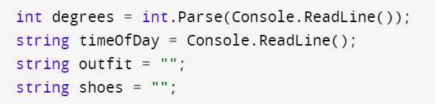
- Check the temperature using logical operator "and" (&&). Example: "degrees >= 10 && degrees <= 18" Within the temperature check, consider the time of the day: Morning, Afternoon, Evening by changing the value of the variables "outfit, shoes" for each stage of the day.
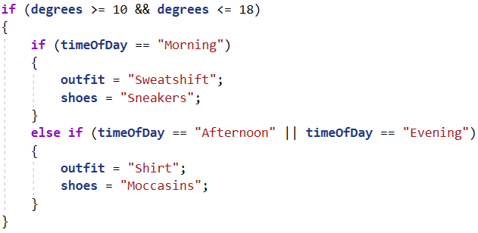
- Print the result on the console following the format outlined in the task description.

